EXPT NO:8 | FORECASTING AND PREDICTIVE ANALYTICS USING TABLEAU  AND POWER BI
DATE: 14.08.2026

PRE-LAB QUESTIONS (PROVIDE BRIEF ANSWERS TO THE FOLLOWING QUESTIONS)
- What is forecasting in the context of Business Intelligence (BI)?
Forecasting in Business Intelligence is the process of predicting future trends based on past and current data. It helps businesses estimate future sales, demand, or profits. BI tools like Tableau and Power BI use historical data to create forecasts. This supports better planning and decision-making. It also helps organizations reduce risks and prepare for future opportunities. Accurate forecasting improves overall business performance.

- Explain the difference between predictive analytics and descriptive analytics.
Descriptive analytics explains what has already happened by analyzing past data. Predictive analytics uses historical data and statistical methods to predict future outcomes. Descriptive analytics focuses on understanding trends, while predictive analytics focuses on forecasting. Both help organizations make informed decisions. Predictive analytics supports future planning, while descriptive analytics helps evaluate past performance. Together, they improve business strategies.

- Name two common forecasting methods used in Tableau and Power BI.
Two common forecasting methods are Time Series Forecasting and Exponential Smoothing. These methods analyze historical data to predict future values. Tableau mainly uses Exponential Smoothing for forecasting. Power BI also supports forecasting through built-in analytics and machine learning models. These methods help identify trends and seasonal patterns. They are widely used for business planning and decision-making.

- Why is data granularity important for accurate forecasting?
Data granularity refers to the level of detail in the data. More detailed and accurate data usually produces better forecasting results. Poor or inconsistent data can reduce prediction accuracy. Choosing the right level of granularity improves business insights. It also helps detect patterns that may be missed in summarized data. High-quality granular data increases the reliability of forecasts.
- Name two challenges in forecasting using multiple data sources.
One challenge is inconsistent data formats from different sources. Another challenge is missing or duplicate data, which affects forecast accuracy. Combining data from multiple systems can also be time-consuming. Proper data cleaning and integration are important for reliable forecasting. Data from different sources may also have different update times. Ensuring data consistency is essential for generating accurate predictions.

IN-LAB EXERCISE:
OBJECTIVE:
To perform time series forecasting and predictive analytics on historical sales data using Tableau and Power BI, and visualize future trends for informed decision-making. PROCEDURE:
- Data Collection:
  - Import historical sales data from multiple sources:
    - Dataset 1: Sales Data (CSV) → Order ID, Order Date, Region, Sales Amount
    - Dataset 2: Promotions Data (Excel) → Promotion ID, Region, Promotion Start Date, Promotion End Date, Discount
- Data Preparation and Transformation:
  - Clean data: standardize date formats, remove duplicates, handle missing values.
  - Aggregate sales data at the required granularity (daily, weekly, or monthly).
  - Ensure numeric fields (Sales, Discount) are correct.
- Data Integration and Modeling:
  - Tableau: Connect datasets and relate them using the Region field.
  - Power BI: Create relationships in the Model view; define cardinality where necessary.
- Forecasting and Predictive Analytics:
  - Tableau:
    - Use the Forecast feature on Sales over time. o Apply trend models like Exponential Smoothing and visualize prediction intervals.
  - Power BI:
    - Use built-in forecasting in line charts. o Optionally, create a DAX measure for predicted sales using moving averages or linear regression.
- Create Calculated Fields:
  - Forecasted Sales = Predicted value from the model
  - Sales Growth % = ((Forecasted Sales – Actual Sales) / Actual Sales) * 100
- Design a Comprehensive Dashboard:
  - Line chart showing actual vs. forecasted sales over time.
  - KPI cards: Total Forecasted Sales, Expected Growth %.
  - Use combo charts to show sales trends along with promotion periods.
  - Highlight regions with expected growth above or below target thresholds.
- Validate Forecast Accuracy:
  - Compare forecasts against actual historical sales (back-testing).
  - Adjust forecasting parameters if necessary (e.g., seasonality length, smoothing factor).
- Publishing and Sharing:
  - Tableau: Publish workbook to Tableau Public or Tableau Server.
  - Power BI: Publish report to Power BI Service and share with stakeholders.
Experiment Datasets:
  - Dataset 1: Historical Sales Data (CSV) → Order ID, Order Date, Region, Sales
  - Dataset 2: Promotions Data (Excel) → Promotion ID, Region, Promotion Start/End Date, Discount

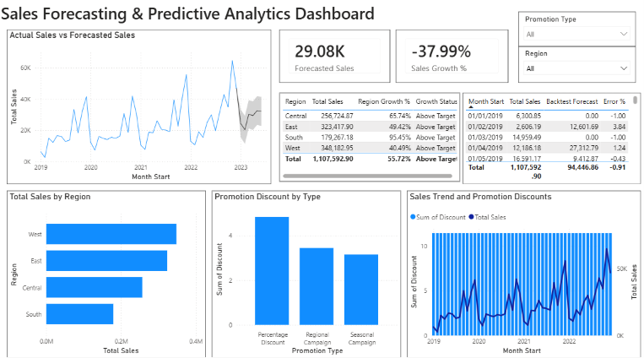
POWER BI

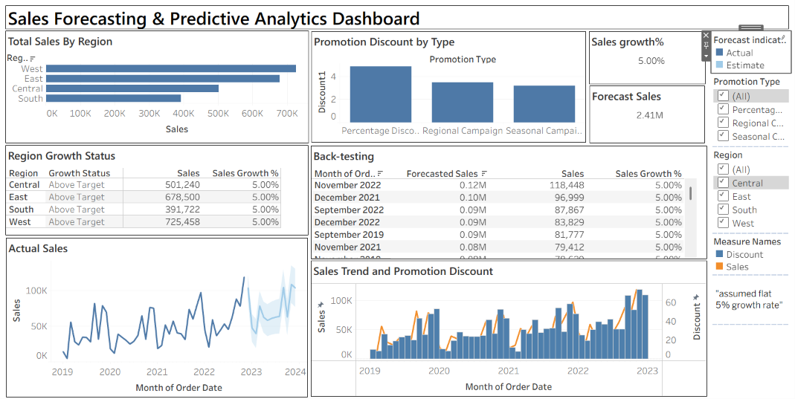
TABLEAU

POST-LAB QUESTIONS (PROVIDE BRIEF ANSWERS TO THE FOLLOWING QUESTIONS)
- How did forecasting help in predicting future sales trends for business planning?
Forecasting helped us estimate future sales by analyzing historical sales data. It identified patterns and seasonal trends that may continue in the future. This allowed the business to plan inventory, marketing campaigns, and staffing more effectively. It also reduced the risk of overstocking or stock shortages. Overall, forecasting supported better planning and improved business decisions.

- What forecasting method did you use, and why was it suitable for the dataset?
We used the Exponential Smoothing forecasting method available in Tableau and Power BI. This method is suitable because it works well with time-series data and gives more importance to recent observations. It can also identify trends and seasonal changes in sales. The method is simple, reliable, and provides accurate predictions for business data. It helped generate meaningful sales forecasts.

- What challenges, if any, did you face regarding missing data or irregular time intervals?
One challenge was handling missing values and duplicate records in the datasets. Some date formats were inconsistent and had to be standardized before analysis. Irregular time intervals also affected the forecasting results. Data cleaning and proper aggregation helped improve the quality of the analysis. These steps made the forecasts more accurate and reliable.

- How can predictive analytics influence decision-making in a retail environment?
Predictive analytics helps retailers understand future customer demand and sales trends. It supports better inventory management and reduces unnecessary stock. Businesses can also plan promotions and pricing strategies more effectively. It helps managers make faster and more informed decisions based on data. This improves customer satisfaction and increases overall profitability.

- What additional data (e.g., competitor pricing, economic indicators) could be integrated to improve forecast accuracy?
Additional data such as competitor pricing, customer feedback, and economic indicators can improve forecast accuracy. Weather conditions, holiday seasons, and market trends may also influence sales. Social media trends and promotional campaign data can provide useful insights. Including these factors helps create more realistic and accurate forecasts. This enables businesses to make better strategic decisions.

RESULT:
The historical sales and promotions datasets were successfully cleaned, integrated, and modeled in Tableau and Power BI. Forecasting techniques provided predicted sales trends, growth percentages, and region-wise performance expectations. The resulting dashboards allowed managers to visualize actual vs. forecasted sales, enabling better planning and datadriven decision-making.

ASSESSMENT

Description |  | Max Marks | Marks Awarded
Pre Lab Exercise |  | 5
In Lab Exercise |  | 10
Post Lab Exercise |  | 5
Viva |  | 10
 | Total | 30
 | Faculty Signature

